**Report.pdf Project 2-2 Report**

**Daniel Rozen drozen3 903104846**

**Part 1:**

* **Figure 1 Bollinger Band strategy chart.**

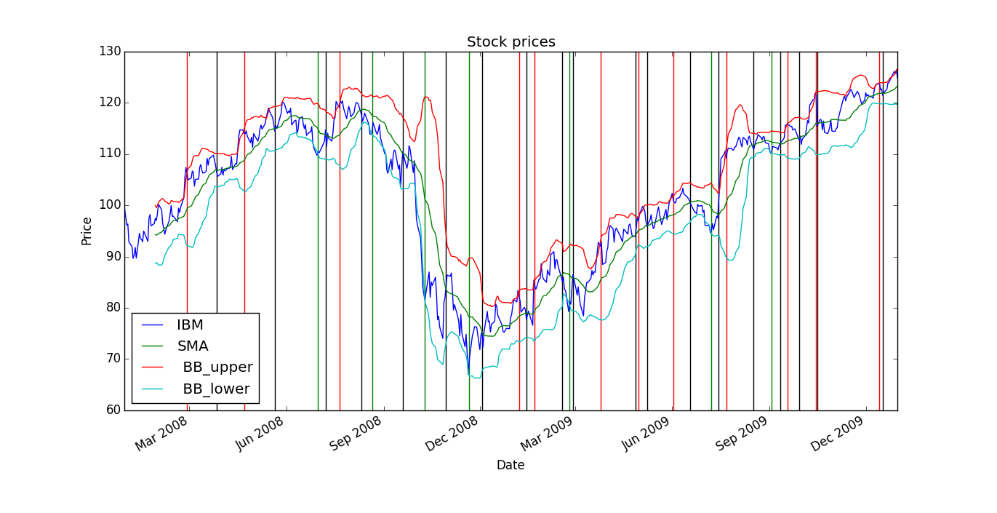

* **Figure 2 Bollinger Band strategy backtest chart.**

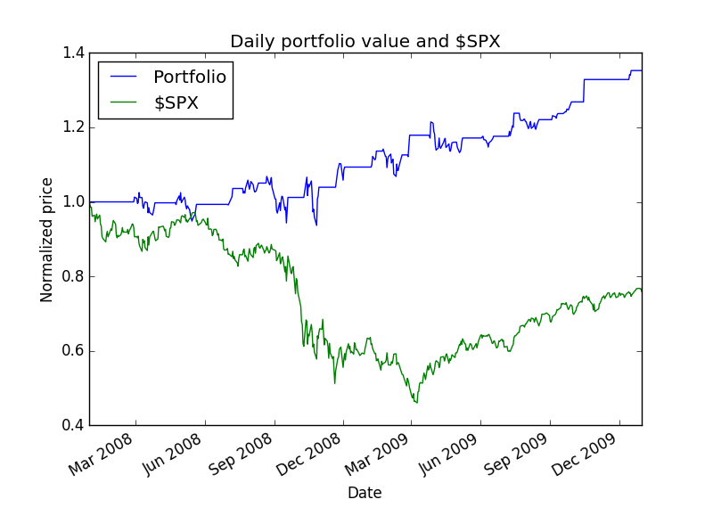

* **Summary of Bollinger Band backtest performance metrics**

Data Range: 2007-12-31 to 2009-12-31

Sharpe Ratio of Fund: 0.959316358968

Sharpe Ratio of $SPX: -0.21996865409

Percent diff: 0.468299497235

Cumulative Return of Fund: 0.3524

Cumulative Return of $SPX: -0.240581328829

Percent diff: 0.63042869151

Standard Deviation of Fund: 0.0108659887337

Standard Deviation of $SPX: 0.0219524869863

Percent diff: 0.0328872168904

Average Daily Return of Fund: 0.000656645285408

Average Daily Return of $SPX: -0.000304189525556

Percent diff: 0.501183626582

Final Portfolio Value: 13524.0

**Part 2:**

* **Written description of your strategy idea.**

We calculate the Bollinger value of IBM with the following formula:

bollingerValue = 2*(price - SMA) / (BB_up - BB_low)

Then we compute the daily change of the bollinger Value with the formula:

daily_change = (df/ df.shift(1)) - 1

We then plotted the graph of the daily change of the Bollinger Value along with the normalized IBM price as follows:

(I multiplied the normalized IBM price by 20 and gave it a -20 offset in order to magnify the price change relative to the daily change of the Bollinger value for ease of viewing)

**Figure 3: Chart Illustrating Strategy Idea:**

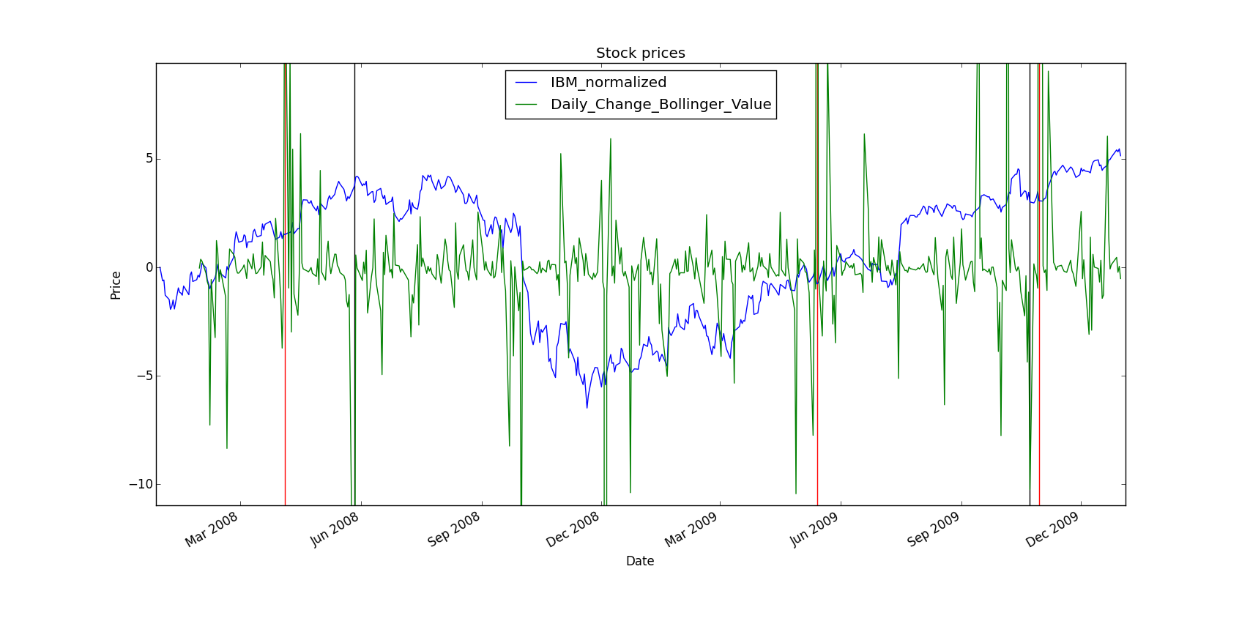

.Long entries are indicated by red vertical lines and long exits by black vertical lines.

Upon inspection it appeared that the IBM stock price increased after there was a high value of the daily change of the Bollinger Value and vice versa, it decreased after there was a low value of the daily change of the Bollinger Value.

We set the threshold of Daily Return of the Bollinger value to 10. If it’s greater than 10, then buy 100 shares, if less than -10, then sell 100 shares. A sell always followed a buy.

This was a purely long strategy.

There is a logical reason to believe this strategy since highly increasing Bollinger values may indicate time to buy, since they indicate that the stock price might go up. Then this strategy holds onto these stocks until a decrease in price may be forecasted by highly decreasing Bollinger values, which indicates a time to sell, in order to maximize gains.

**Figure 4: Backtest chart of strategy.**

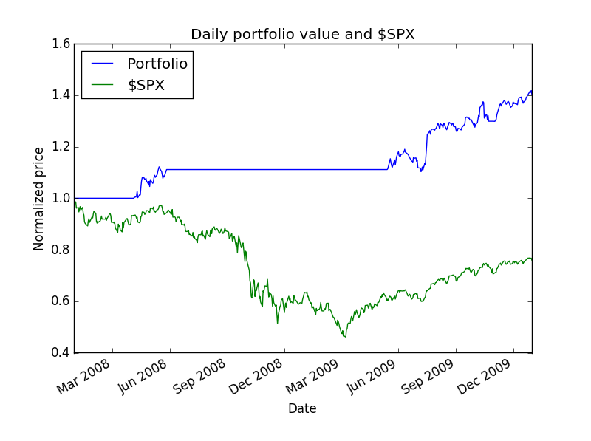

* **Summary of backtest performance metrics.**

Data Range: 2007-12-31 to 2009-12-31

Sharpe Ratio of Fund: 1.61910730632

Sharpe Ratio of $SPX: -0.21996865409

Percent diff: -12.3557765118

Cumulative Return of Fund: 0.4023

Cumulative Return of $SPX: -0.240581328829

Percent diff: -2.67775304439

Standard Deviation of Fund: 0.00679144668578

Standard Deviation of $SPX: 0.0219524869863

Percent diff: 11.5688828398

Average Daily Return of Fund: 0.000692687990205

Average Daily Return of $SPX: -0.000304189525556

Percent diff: -0.834614431751

Final Portfolio Value: 14023.0

* **Analysis of the performance of strategy idea over the 2008-2009 period.**

As we see from the Summary of backtest performance metrics, the strategy performed a Cumulative Return of Fund of 0.4023 which is greater than 0.3524 of the Bollinger Band strategy.

Investigating Figure 3, we see that April 4, 2008 we buy before a large increase until May 27, 2008 where we sell, then again in May 14, 2009 we buy before a large overall increase in around October 10, 2009, and buy again in October 30, and hold just before a large increase in price till Dec 31, 2009. I assume these would be sold at some time beyond Dec 31, 2009 before the stock price fell significantly.

Figure 4 indicates an mainly overall increase in portfolio value, performing much better than SPY.